 | Sutherland Shire Reconciliation in 2025  We acknowledge the Dharawal language speaking people of the Gweagal and Norongerragal clans, as the traditional custodians of the lands within the Sutherland Shire. We are grateful for their immemorial care of the lands and waterways on which we live and work.
Who we are … Sutherland Shire Reconciliation Incorporated is a not-for-profit community organisation. Our Committee is comprised of both Indigenous and non-Indigenous volunteers working together. We are a member organisation of Reconciliation NSW and work collaboratively with community and other organisations who share our values and goals. We work closely with organisations such as: Gandangara Local Area Land Council, the Sutherland Aboriginal Education Consultative Group; the Sutherland Shire Council, the Kurranulla Aboriginal Corporation and ANSTO, a major sponsor.
What we do … We promote Reconciliation through advocacy, events, and projects that prioritise the needs of First Nations people living in the Sutherland Shire, and that acknowledge our true shared histories and First Nations People’s ancient knowledge and culture.
Events we host or support…
Yarning Circles where we get to know a little about each other and then hold a discussion on a set topic.  Journeys into Understanding where we learn more about First Nations history and culture and current issues that impact all our communities.  Commemorative Events including the Sunset Ceremony (Jan), a dawn vigil for Sorry Day (May) the Appin Massacre (April), Mabo Day (June)  Cultural Celebrations in National Reconciliation Week, NAIDOC Week | 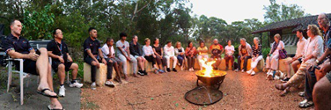  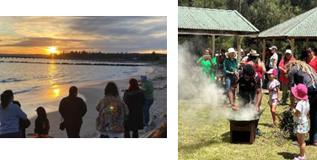
Our Projects …
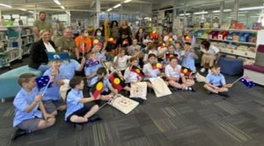 | In 2021-2022, we created a School Gift Pack that was gifted to First Nations Primary-aged students & families in the Sutherland Shire at special school ceremonies. The goal of the project was to share the local Dharawal language and build community and pride in culture.

In 2023 we distributed the popular Dharawal Picture Dictionary to over 14,000 families in Sutherland Shire primary schools. We are currently working with ANSTO to make the Picture Dictionary a sustainable and affordable resource for educational settings, cultural organisations and families. | 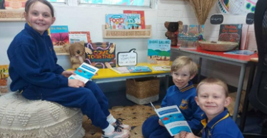
We are also working with the Woronora Memorial Park to develop the Aboriginal area of the park to be suitable for Aboriginal mourning and celebrations of life.
How to get involved …
There are many ways to show respect and a willingness to both understand and offer support. By joining our events and participating in our projects you will meet like-minded people, both non-Aboriginal and Aboriginal walking together on this journey. If you would like to learn more or become a member go to our website
http://www.sutherlandshirereconciliation.org or email us at mailto:suthsrec@gmail.com

